Phonics  Please click on the link and ensure your child knows the phase 2 and 3 sounds on the Little Wandle website: https://www.littlewandlelettersandsounds.org.uk/resources/for-parents/  This week we have been learning the split digraphs: a-e/i-e/o-e/ue  Please scroll to look at this week’s sheet. Practise reading the sounds and the words from this week.  Challenge Can you write a sentence with as many split digraphs as possible? eg. I made a game with a slide at home. |  | Reading  Your child needs to log in to their on-line book bag here:  Collins Ebooks  Please read with your child at least three times a week and add a comment in the reading record.  Please bring back your child’s reading record to school by the following Thursday so that it can be seen.  In addition, your child will bring home a school library book on Thursdays. This book is for sharing. Please enjoy the book together and return it the following Thursday so it can be changed. Your child will not be able to take another library book until it is returned.  Happy Reading!  * Thursday - return reading record and library book!*
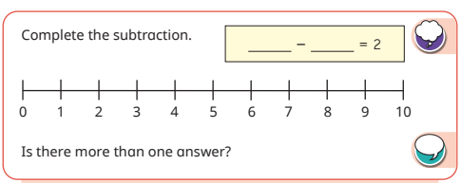
Maths Challenge:
This week we have been learning how to use number line
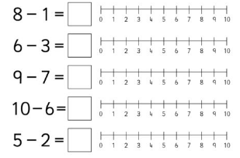
to work out subtractions within 10.

